BIT503 - Fundamentals of Information Technology
Assessment 2

Thomas Bernard
Student ID: 5142644
15th September 2025

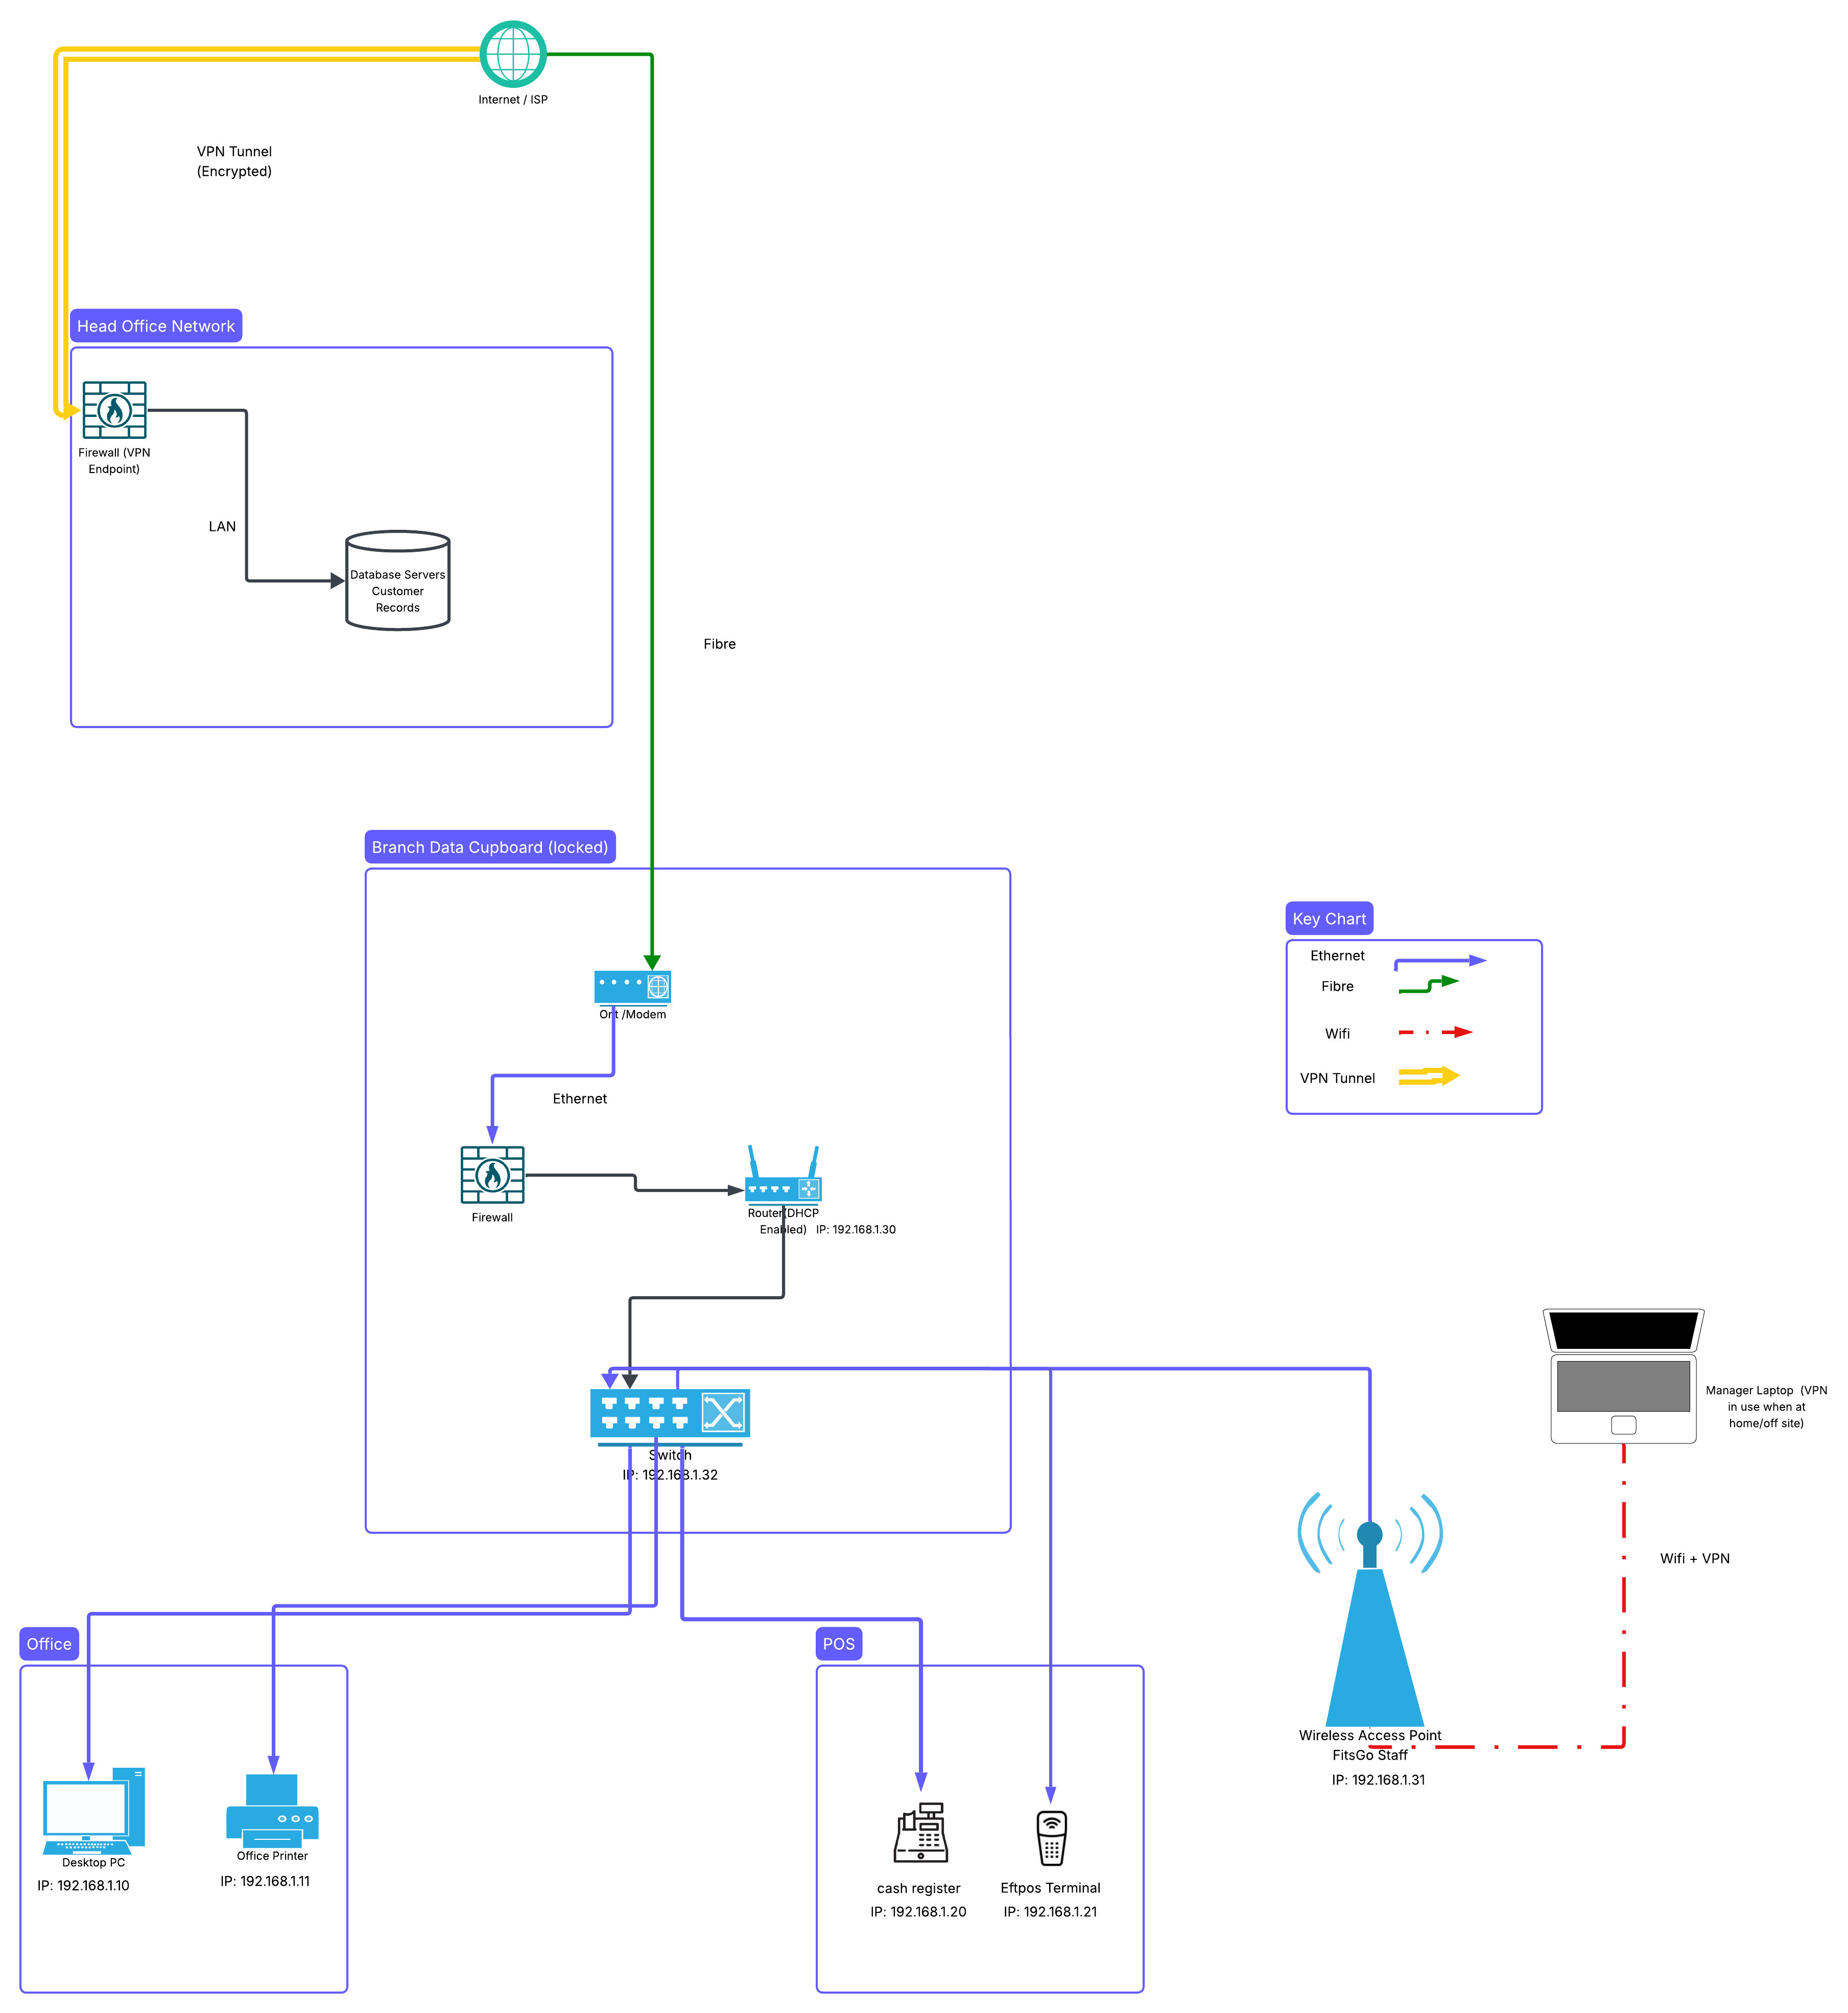
Part 1: Network diagram
Part 2: Network security
Firewall
A firewall is a security tool at the network level it checks all connections and does the rules that match the business needs. Security system requires setups for all ports and protocols examples are database queries, from all the FitsGo Branches and outbound traffic that will go to a cloud service. FitsGo can block unwanted inbound requests and limit services if required, sectors the network for example you can use a separate subnet for FitsGo database and all the staff devices you can enforce different rules for devices. I would recommend logging everything as it makes it easier for audits and if any incidents happen Firewall Protects the server database at head office, FitsGo Gym, LAN, their desktops, switches, Wireless Access Points, and any routers connected to network. The network is also protected from the head office to the cloud provider FitsGo uses. FitsGo should place firewalls at all locations, Head Office, All FitsGo locations via router firewalls and you would want to use internal rules around the database subnet.

VPN
“A VPN, which stands for virtual private network, establishes a digital connection between your computer and a remote server owned by a VPN provider, creating a point-to-point tunnel that encrypts your personal data, masks your IP address, and lets you sidestep website blocks and firewalls on the internet. This ensures that your online experiences are private, protected, and more secure” (Microsoft, n.d., para. 1). It is vital that FitsGo uses a VPN. It protects all FitsGo Gyms, and their Head offices and ensures all data is secure and encrypted via the VPN. The VPN needs to have secure complex passwords and a two-step authentication for good security. A VPN helps to ensure all data is not exposed to the open internet. VPN secures Customer Data between gyms and the head office; it protects all staff logins and secure backups from the head office to the cloud provider. It logs all actions, for example all logins and failed attempts, ensure to check logs and any security alerts often for safety reasons.

Part 3: Networking concepts.
1. What are the primary responsibilities of a router in a network, and how does it manage traffic between different networks?
A router joins different networks together. It connects to your Local Network, in the home or business to your ISP Internet provider. The router provides access to the world wide web Internet. You can use a firewall to protect your network; it makes sure the traffic goes the right way and is protected.
2. What features and services does a network switch provide, and how does it enhance the performance of a network for FitsGo?
Network switches are used to connect devices within the network, it can be printers, computers, servers at FitsGo, it makes sharing easier.

3. Identify a software solution that ensures secure remote access to a network. Explain its mechanism and its practical application for FitsGo.
FitsGo could use TeamViewer, it is a secure remote access software; it allows authorized people to control the computers and servers over the internet. You can install TeamViewer on FitsGo computers and servers, and every device where TeamViewer is installed on it will get a unique ID. Then you would add that computer or server to your account for easy access. The IT professional at FitsGo would login using company credentials with two step authentications. Once logged in you then would select the pc or server you want to connect to; the TeamViewer software is secure it uses strong encryption and security protocols. The TeamViewer software is designed to work with firewalls and routers on the network.
4. Describe the process by which devices in a network receive their IP addresses. Discuss the difference between static and dynamic IP addressing and their implications for wired and wireless devices.
Devices get their IP Addresses either Manually or automatically. Most routers give an IP address when a device connects, for example when a TV or phone connects to the network. The other IP address is static IP and that must be set manually. This will never change as it is used for servers and devices that need to have the same IP address each time on the network.

5. Compare internet service plans from two different internet service providers (ISPs). Include details of each plan’s cost, bandwidth, and data limits, and evaluate their suitability for FitsGo.
Figure 1
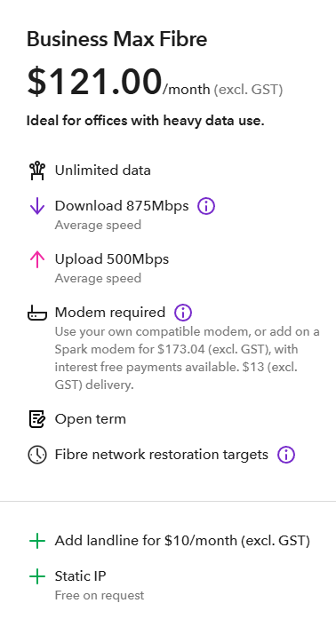
(Spark, 2025)

Figure 2
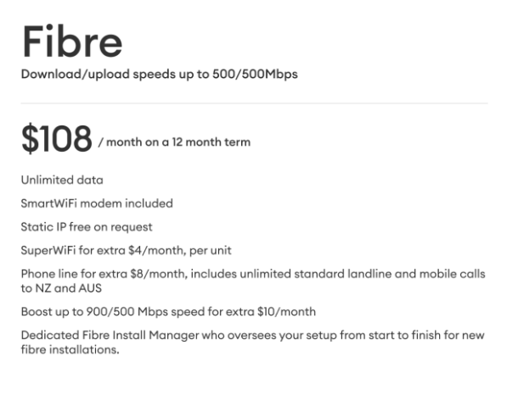
(One NZ, 2025)
On the Spark Business Max Fibre plan at $121 per month, you get 875 Mbps download and 500 Mbps upload speeds, static IP is free on request, and the modem is extra. With the One NZ Fibre Plan at $108 per month, you get 500 Mbps download and 500 Mbps speeds, modem included, static IP free on request, and a $10 increase to 900 Mbps download and 500 Mbps upload.
When comparing them both I would Recommend FitsGo to go with One NZ. FitsGo benefits from the boost's higher download speed, robust upload, included modem, and lower monthly cost than Spark does. Spark is a good option for Smaller Branches that need an open term.

Task 2: Diagnostic testing and maintenance
Part 1: Diagnostic tools
Device Manager
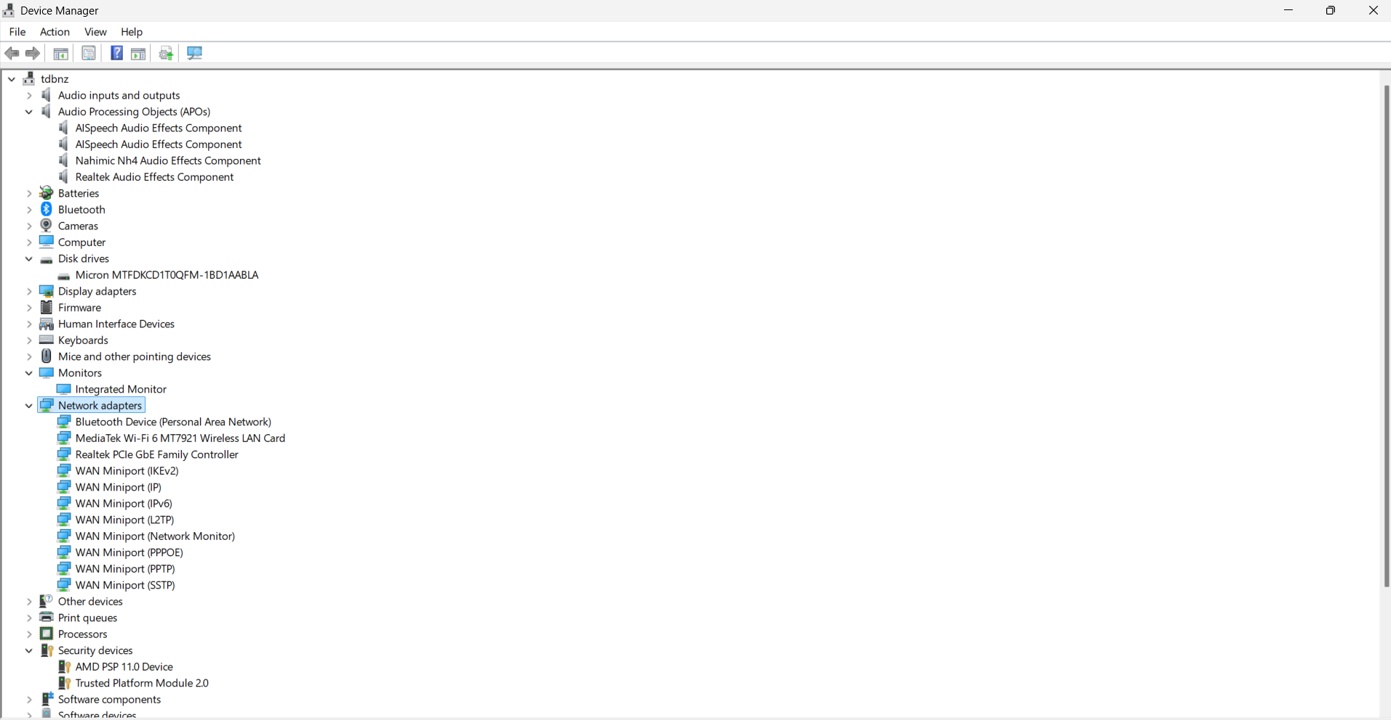
The laptop is running Windows 11 Pro operating system; it is a Lenovo branded laptop. We looked at the Device Manager and there were no issues found on the system. If there are errors, typically device manager would show a yellow warning symbol⚠️next to the device that has an issue. This could mean that there is no driver installed, so we would have to install a driver on pc or point it to the correct driver. Then the device should resolve itself and operate correctly and do a reboot to ensure the system is all good to go.

Task Manager
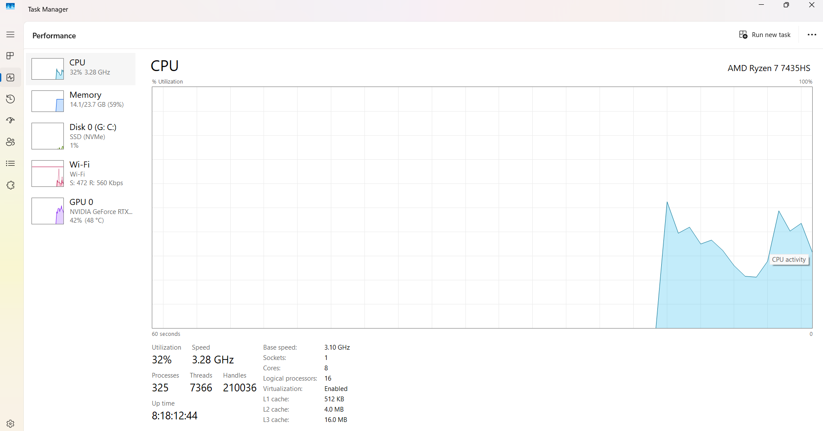
The laptop is running windows 11 Pro Operating System we had a look at Task Manager on the laptop and the results that are shown look normal. All Data we see on the graph, for example Memory CPU are looking good and healthy. If the computer did not have enough memory, for example, it would show you higher graphs and statistics. This laptop is performing well, no further things need to be assessed or done to this device at this time. We would look again in the future when we conduct further maintenance checks.

Part 2: Consumption
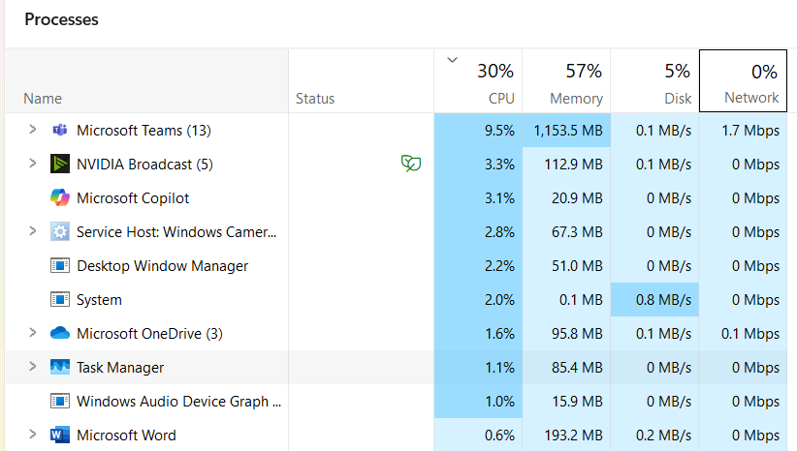
We had a look at the laptop it is running windows 11 pro we went to task manager. We were able to see what the top two CPU processes were in this case Microsoft Teams and NVIDIA Broadcast were the highest consuming process at this time. The total CPU used on the computer at this this time is 30% all the stats are perfectly normal and there are no issues identified with this laptop.

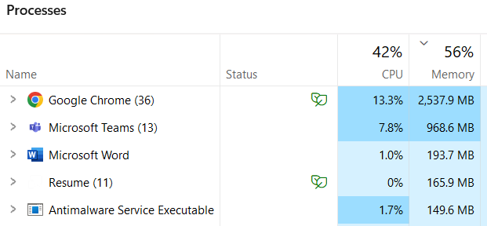

We had a look at the laptop, it is running windows 11 pro. We started up Task Manager (Ctrl + Shift + Esc) and we are trying to identify the top two memory processes. We went to the processes tab, and we saw that the memory is 56%. Google Chrome has higher memory processes compared to Microsoft Teams, which is 2nd in the list of highest memory processes. At the time, the overall stats shown are good and the computer can manage the tasks effectively and is running smoothly as this device has good amount of memory.
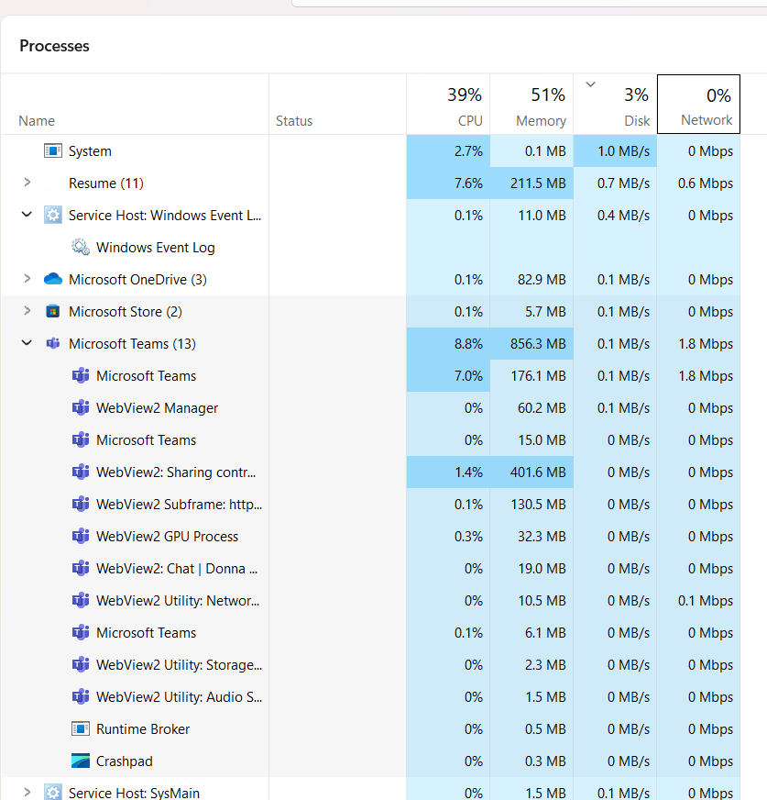
We had a look at the laptop, it is running windows 11 pro. We started up Task Manager (Ctrl + Shift + Esc) and we are trying to identify the top two Disk Processes. We went to the processes tab, and we saw that the disk is 3%. System is the highest Process followed by service Host at the time the overall stats shown are good and the computer can manage the tasks effectively and is running smoothly.

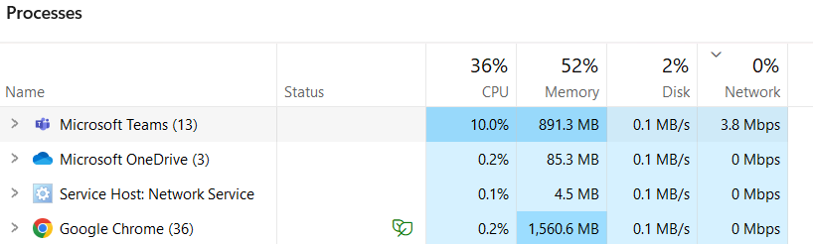
We had a look at the laptop, it is running windows 11 pro. We started up Task Manager (Ctrl + Shift + Esc) and we are trying to identify the top two Networking Process. We went to the processes tab, and we saw that the network is 0%. The highest networking process currently is Microsoft Teams as the client is currently on video call. Microsoft OneDrive is running to back up the computer, by looking at the stats it all looks good and normal. If they are having internet issues, then it would be best to run a speed test and contact Internet service provider if necessary.

Part 3: Maintenance
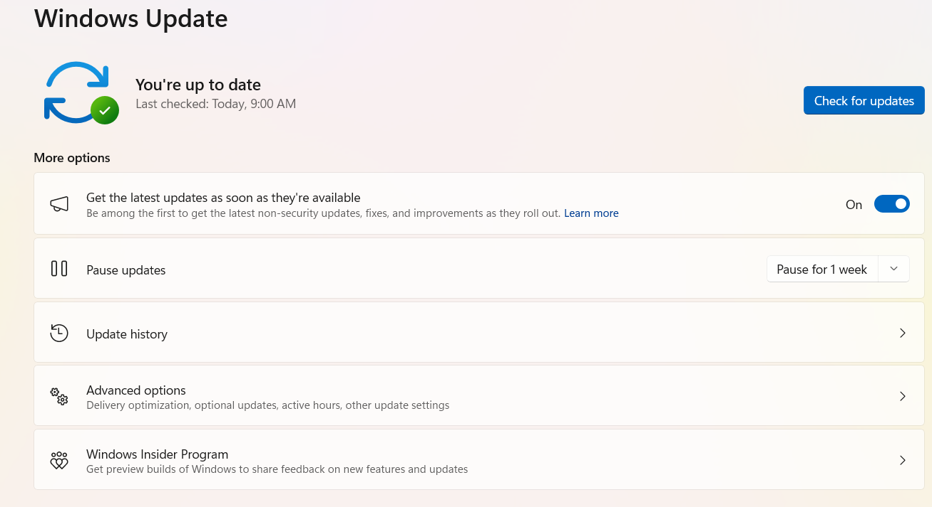
System Update

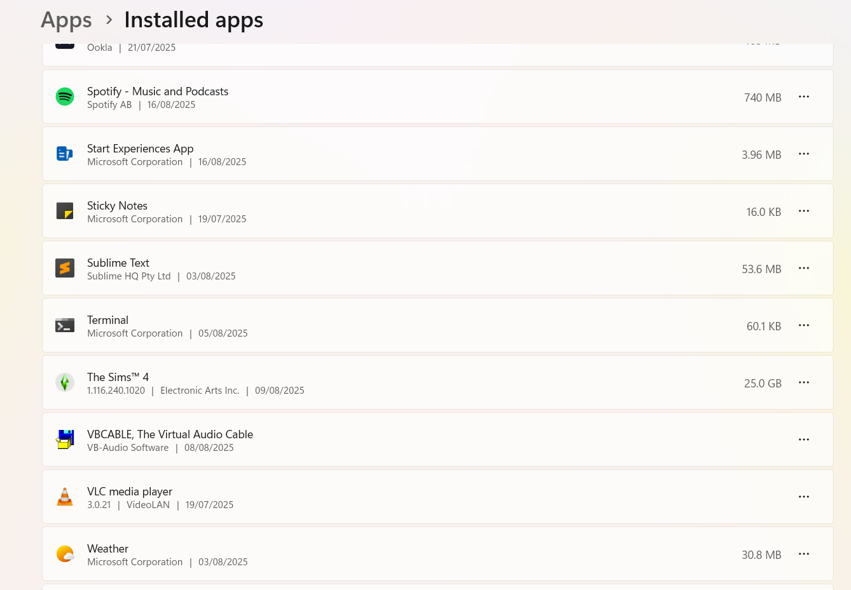
Software
We had a look at the laptop, it is running windows 11 pro. We looked at the installed programs and the client had a range of applications installed. The client said they do not use Spotify anymore as their subscription expired, we then found it on the list of programs and uninstalled it.

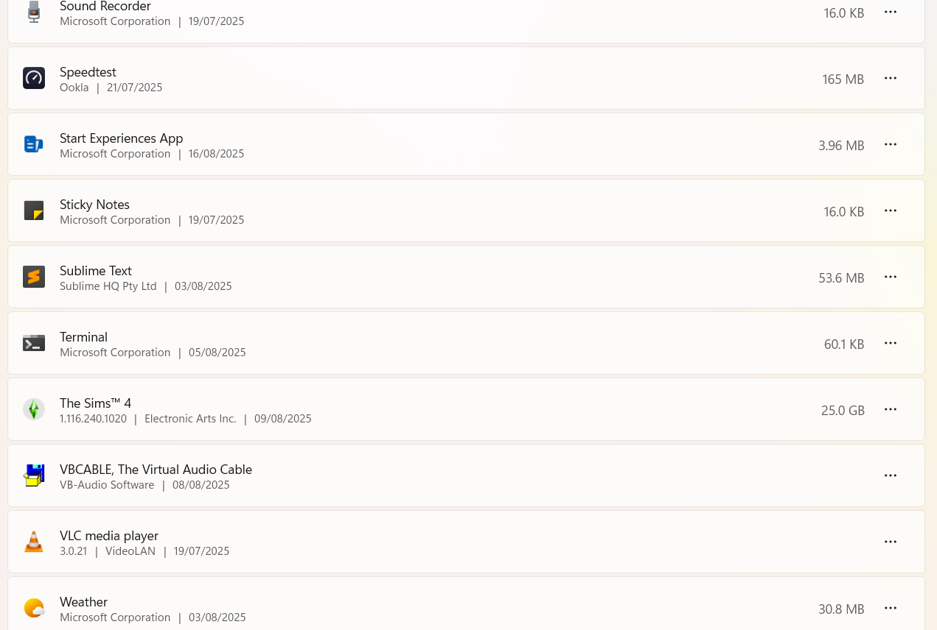
After consulting the client, they said they did not use Spotify anymore we selected that program on the list and we uninstalled it completely. Since removing the program, it freed up more space on the computer and the client is now happy that the unwanted program has been removed from the laptop.

Disk space
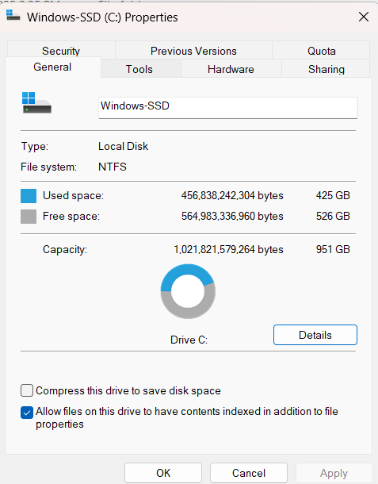

425GB Used Space
526GB Free Space
On C Drive on Laptop

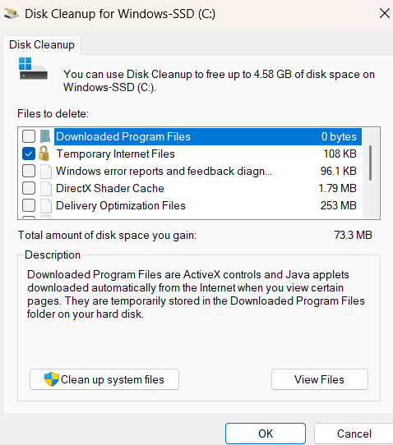
We used Disk Cleanup tool on windows to remove some unnecessary files on laptop.
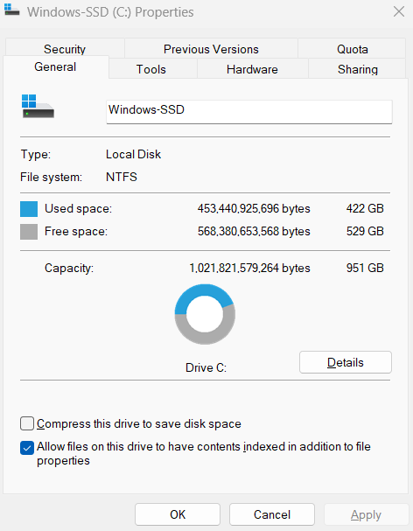
425GB Used Space
529GB Free Space
On C Drive on Laptop
After the cleanup on the laptop we got 529GB Now which means we have 3GB of more space now available on Hard Drive.

Backup
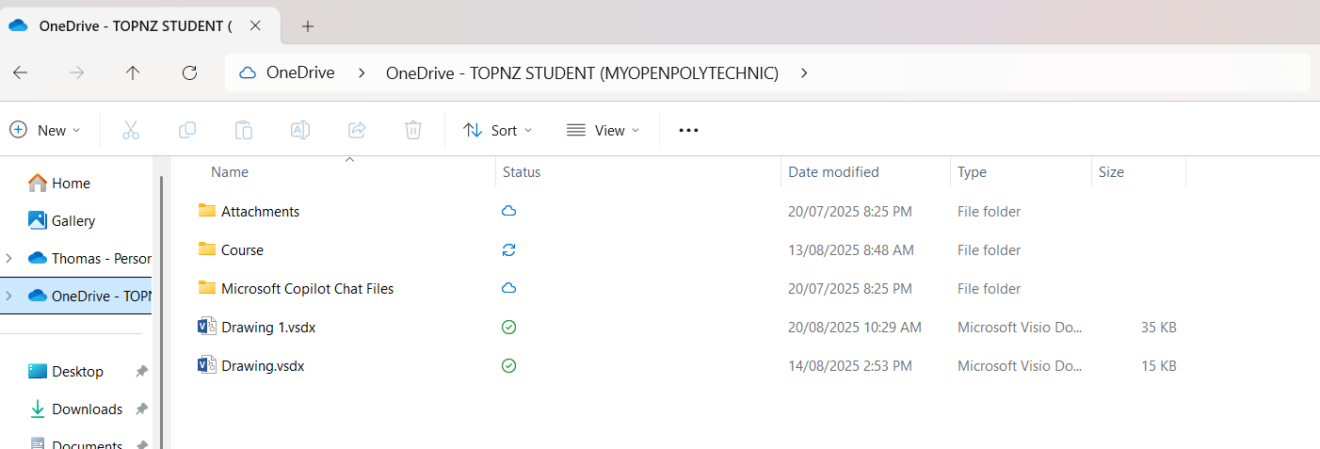

On the Windows Laptop we have installed OneDrive, and we have added files to it so it will back up the important documents to OneDrive. In this case it was their course files that they needed to back up offsite. With this now backed up we can now access this from any device, and it now gives the user peace of mind in case they lose their copies locally on their device.

References
Microsoft. (n.d.). What is a VPN? Why should I use a VPN? https://azure.microsoft.com/en-us/resources/cloud-computing-dictionary/what-is-vpn
One NZ. (2025). Broadband plans. https://one.nz/business/broadband/broadband-plans/

Spark. (2025). Broadband plans. https://www.spark.co.nz/online/business/shop/broadband/buy-plan

